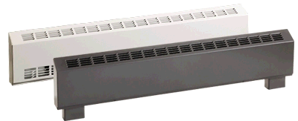


905 Series: HX-905U (Sloped Top)
How to order: Model + Heater Code with color code + Option (example HX-905U01250NW-1708-T5)
Length  In. (mm) | Density |  | Watts | Heater Code |  |  |  |  |  |  |  |  |  | Watts at 240/208V | Heater Code
Length  In. (mm) | W/Ft | W/m | Watts |  | 120V | Amps |  | 208V | Amps |  | 277V | Amps |  | Watts at 240/208V | 240/208V | Amps
28.8  (731) | 100 | 330 | 200 |  | 00200B‡-731 | 1.7 |  | 00200C‡-731 | 1.0 |  | ― | — |  | 200/150 | 00200V‡-731 | 0.8/0.7
28.8  (731) | 150 | 490 | 300 |  | 00300B‡-731 | 2.5 |  | 00300C‡-731 | 1.4 |  | 00300N‡-731 | 1.1 |  | 300/225 | 00300V‡-731 | 1.3/1.1
28.8  (731) | 200 | 650 | 400 |  | 00400B‡-731 | 3.3 |  | 00400C‡-731 | 1.9 |  | 00400N‡-731 | 1.4 |  | 400/300 | 00400V‡-731 | 1.7/1.4
28.8  (731) | 275 | 900 | 500 |  | 00500B‡ | 4.2 |  | 00500C‡ | 2.4 |  | 00500N‡ | 1.8 |  | 500/375 | 00500V‡ | 2.1/1.8
38.8  (986) | 100 | 330 | 300 |  | 00300B‡-986 | 2.5 |  | 00300C‡-986 | 1.4 |  | 00300N‡-986 | 1.1 |  | 300/225 | 00300V‡-986 | 1.3/1.1
38.8  (986) | 150 | 490 | 450 |  | 00450B‡-986 | 3.8 |  | 00450C‡-986 | 2.2 |  | 00450N‡-986 | 1.6 |  | 450/338 | 00450V‡-986 | 1.9/1.6
38.8  (986) | 200 | 650 | 600 |  | 00600B‡-986 | 5.0 |  | 00600C‡-986 | 2.9 |  | 00600N‡-986 | 2.2 |  | 600/450 | 00600V‡-986 | 2.5/2.2
38.8  (986) | 275 | 900 | 750 |  | 00750B‡ | 6.3 |  | 00750C‡ | 3.6 |  | 00750N‡ | 2.7 |  | 750/563 | 00750V‡ | 3.1/2.7
49  (1246) | 100 | 330 | 400 |  | 00400B‡-1246 | 3.3 |  | 00400C‡-1246 | 1.9 |  | 00400N‡-1246 | 1.4 |  | 400/300 | 00400V‡-1246 | 1.7/1.4
49  (1246) | 150 | 490 | 600 |  | 00600B‡-1246 | 5.0 |  | 00600C‡-1246 | 2.9 |  | 00600N‡-1246 | 2.2 |  | 600/450 | 00600V‡-1246 | 2.5/2.2
49  (1246) | 200 | 650 | 800 |  | 00800B‡-1246 | 6.7 |  | 00800C‡-1246 | 3.8 |  | 00800N‡-1246 | 2.9 |  | 800/600 | 00800V‡-1246 | 3.3/2.9
49  (1246) | 275 | 900 | 1000 |  | 01000B‡ | 8.3 |  | 01000C‡ | 4.8 |  | 01000N‡ | 3.6 |  | 1000/750 | 01000V‡ | 4.2/3.6
58.6  (1486) | 100 | 330 | 500 |  | 00500B‡-1486 | 4.2 |  | 00500C‡-1486 | 2.4 |  | 00500N‡-1486 | 1.8 |  | 500/375 | 00500V‡-1486 | 2.1/1.8
58.6  (1486) | 150 | 490 | 750 |  | 00750B‡-1486 | 6.3 |  | 00750C‡-1486 | 3.6 |  | 00750N‡-1486 | 2.7 |  | 750/563 | 00750V‡-1486 | 3.1/2.7
58.6  (1486) | 200 | 650 | 1000 |  | 01000B‡-1486 | 8.3 |  | 01000C‡-1486 | 4.8 |  | 01000N‡-1486 | 3.6 |  | 1000/750 | 01000V‡-1486 | 4.2/3.6
58.6  (1486) | 275 | 900 | 1250 |  | 01250B‡ | 10.4 |  | 01250C‡ | 6.0 |  | 01250N‡ | 4.5 |  | 1250/938 | 01250V‡ | 5.2/4.5
67.3  (1708) | 100 | 330 | 600 |  | 00600B‡-1708 | 5.0 |  | 00600C‡-1708 | 2.9 |  | 00600N‡-1708 | 2.2 |  | 600/450 | 00600V‡-1708 | 2.5/2.2
67.3  (1708) | 150 | 490 | 900 |  | 00900B‡-1708 | 7.5 |  | 00900C‡-1708 | 4.3 |  | 00900N‡-1708 | 3.2 |  | 900/675 | 00900V‡-1708 | 3.8/3.2
67.3  (1708) | 200 | 650 | 1250 |  | 01250B‡-1708 | 10.0 |  | 01250C‡-1708 | 5.8 |  | 01250N‡-1708 | 4.3 |  | 1250/938 | 01200V‡-1708 | 5.0/4.3
67.3  (1708) | 275 | 900 | 1500 |  | 01500B‡ | 12.5 |  | 01500C‡ | 7.2 |  | 015000N‡ | 5.4 |  | 1500/1125 | 01500V‡ | 6.3/5.4
76.6  (1945) | 100 | 330 | 700 |  | 00700B‡-1945 | 5.8 |  | 00700C‡-1945 | 3.4 |  | 00700N‡-1945 | 2.5 |  | 700/525 | 00700V‡-1945 | 2.9/2.5
76.6  (1945) | 150 | 490 | 1050 |  | 01050B‡-1945 | 8.8 |  | 01050C‡-1945 | 5.0 |  | 01050N‡-1945 | 3.8 |  | 1050/788 | 01050V‡-1945 | 4.3/3.8
76.6  (1945) | 200 | 650 | 1400 |  | 01400B‡-1945 | 11.7 |  | 01400C‡-1945 | 6.7 |  | 01400N‡-1945 | 5.1 |  | 1400/1050 | 01400V‡-1945 | 5.8/5.0
76.6  (1945) | 275 | 900 | 1750 |  | ― | — |  | 01750C‡ | 8.4 |  | 017500N‡ | 6.3 |  | 1750/1313 | 01750V‡ | 7.3/6.3
85.4  (2168) | 100 | 330 | 800 |  | 00800B‡-2168 | 6.7 |  | 00800C‡-2168 | 3.8 |  | 00800N‡-2168 | 2.9 |  | 800/600 | 00800V‡-2168 | 3.3/2.9
85.4  (2168) | 150 | 490 | 1200 |  | 01200B‡-2168 | 10.0 |  | 01200C‡-2168 | 5.8 |  | 01200N‡-2168 | 4.3 |  | 1200/900 | 01200V‡-2168 | 5.0/4.3
85.4  (2168) | 200 | 650 | 1600 |  | ― | — |  | 01600C‡-2168 | 7.7 |  | 01600N‡-2168 | 5.8 |  | 1600/1200 | 01600V‡-2168 | 6.7/5.8
85.4  (2168) | 275 | 900 | 2000 |  | ― | — |  | 02000C‡ | 9.6 |  | 020000N‡ | 7.2 |  | 2000/1500 | 02000V‡ | 8.3/7.2
94.2  (2393) | 100 | 330 | 900 |  | 00900B‡-2393 | 7.5 |  | 00900C‡-2393 | 4.3 |  | 00900N‡-2393 | 3.2 |  | 900/675 | 00900V‡-2393 | 3.8/3.2
94.2  (2393) | 150 | 490 | 1350 |  | ― | — |  | 01350C‡-2393 | 6.5 |  | 01350N‡-2393 | 4.9 |  | 1350/1013 | 01350V‡-2393 | 5.6/4.9
94.2  (2393) | 200 | 650 | 1800 |  | ― | — |  | 01800C‡-2393 | 8.7 |  | 01800N‡-2393 | 6.5 |  | 1800/1350 | 01800V‡-2393 | 7.5/6.5
94.2  (2393) | 275 | 900 | 2250 |  | ― | — |  | 02250C‡ | 10.8 |  | 022500N‡ | 8.1 |  | 2250/1688 | 02250V‡ | 9.4/8.1
103.4  (2625) | 100 | 330 | 1000 |  | 01000B‡-2625 | 8.3 |  | 01000C‡-2625 | 4.8 |  | 01000N‡-2625 | 3.6 |  | 1000/750 | 01000V‡-2625 | 4.2/3.6
103.4  (2625) | 150 | 490 | 1500 |  | ― | — |  | 01500C‡-2625 | 7.2 |  | 01500N‡-2625 | 5.4 |  | 1500/1125 | 01500V‡-2625 | 6.3/5.4
103.4  (2625) | 200 | 650 | 2000 |  | ― | — |  | 02000C‡-2625 | 9.6 |  | 02000N‡-2625 | 7.2 |  | 2000/1500 | 02000V‡-26252 | 8.3/7.2
103.4  (2625) | 200 | 650 | 2250 |  | ― | — |  | 02250C‡-2625 | 10.8 |  | 02250N‡-2625 | 8.1 |  | 2250/1688 | 02250V‡-2625 | 9.4/8.1
103.4  (2625) | 275 | 900 | 2500 |  | ― | — |  | 02500C‡ | 12.0 |  | 02500N‡ | 9.0 |  | 2500/1875 | 02500V‡ | 10.4/9.0
Other single-phase voltages available. Consult factory. All models listed are single-phase.
‡ Standard colors - Add W for white finish or A for almond finish to the end of catalog number.
Factory Built-in Options
Code | Description
A | Bottom Air Inlet
D3 | Disconnect Switch, 277V Double-pole, 20 Amp
L | Custom Length
M1 | High Altitude Automatic Cutout
R1 | 24V Relay, 240V, 22 Amp; 277V, 19 Amp
R2 | 24V Relay with Transformer, 240V, 22 Amp; 277V, 19 Amp
R6 | Pneumatic Relay, 480V, 25 Amp
R7 | 24V Proportional Relay
S | Smooth Finish on Heater Back
T1 | Tamperproof Thermostat, Single-pole, 277V, 25 Amp with off position
T2 | Tamperproof Thermostat, Double-pole, 277V, 25 Amp with off position
T5 | Adjustable Thermostat, Single-pole, 277V, 25 Amp with off position
T6 | Adjustable Thermostat, Double-pole, 277V, 25 Amp with off position

Field-Installed Options
(shipped loose for field installation into heater)
Catalog  Number | Description
905-124597¶ | Inside Corner
905-124598¶ | Outside Corner
907-124599¶ | Round Pedestal Kit 3-5” High, Qty=2
907-169807¶ | Square Pedestal Kit, 2” High, Qty=2
905-124600¶ | Splice Plate 2” Long
905-124601¶ | Finish Joint for Heater with Pedestal
907-124602 | 24V Relay Kit, 240V/25Amp, 277V/18 Amp
907-124603 | 24V Relay Kit with Transformer,120V, 22 Amps
907-124604 | 24V Relay Kit with Transformer, 208V, 22 Amp
907-124605 | 24V Relay Kit with Transformer, 240V, 22 Amp
907-124606 | 24V Relay Kit with Transformer, 277V, 19 Amp
905B-XXX¶ | Blank Section (specify length in inches-XXX)
907-224755 | Tamperproof Single-pole Thermostat Kit 277V, 25 Amp with off position
907-224756 | Tamperproof Double-pole Thermostat Kit 277V, 25 Amp with off position
907-224757 | Single-pole Thermostat Kit 277V, 25 Amp with off position
907-224758 | Double-pole Thermostat Kit 277V, 25 Amp with off position
¶ Standard colors - Add W for white finish or A for almond finish to the end of part number.

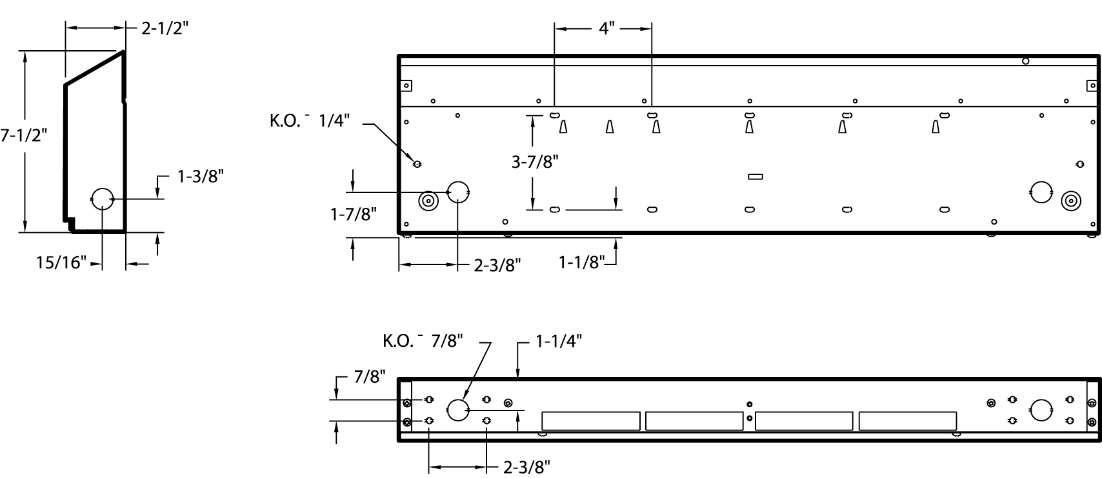
Side View
Rear View
Bottom View

Architect’s and Engineers Specification

Heating Elements – Stainless steel elements with aluminum fins float on high temperature nylon bushings for quiet operation.
Housing – Cabinet is constructed of 18-gauge steel with a 16-gauge steel front cover. The unit has a polyester powder paint finish in white or almond. End caps are provided on all units.
Inlet/Outlet Grilles – The fresh air inlet grille is located on the front of the unit. The outlet grille has openings less than 0.25 inches to discourage tampering with the heating element (pencil-proof).
Built-in Controls – Linear limit, automatic reset thermal cutout.
Electrical Connection – Each baseboard heater has a junction box located on both ends and a built-in full length wireway.
Installation Requirements – Field or factory-installed low voltage relay and thermostat kits fit into the right-hand junction box only. Heaters 200 watt/ft. or greater are not designed for residential use in the United States.

