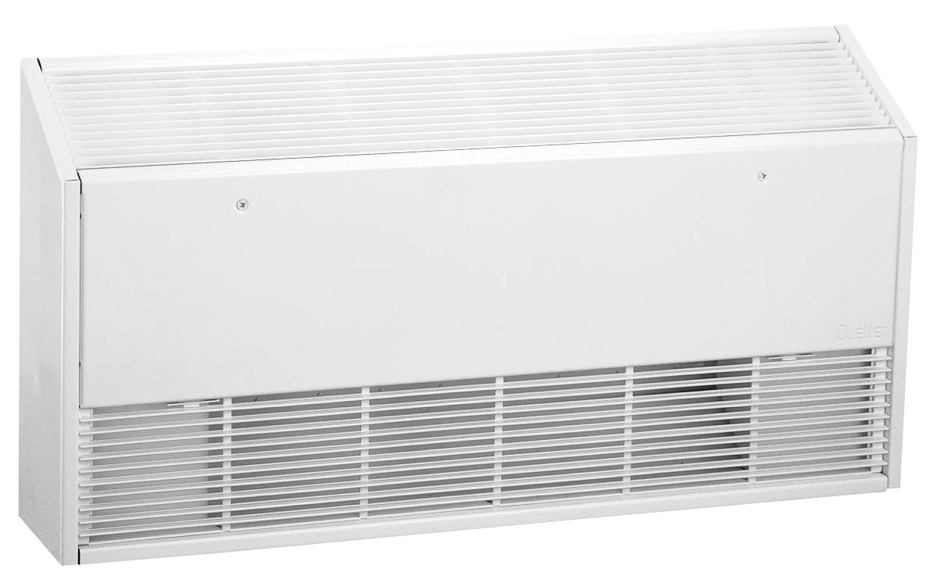


HX-908U (Sloped Top)
How to order: Model + Heater Code with color code + Options (example HX-908U02000NW-1655-T1)
Length  In. (mm) | Density |  | Watts | Heater Code |  |  |  |  |  |  | Watts at 240/208V | Heater Code
Length  In. (mm) | W/Ft | W/m | Watts |  | 208V | Amps |  | 277V | Amps |  | Watts at 240/208V | 240/208V | Amps
27.2  (690) | 375 | 1250 | 800 |  | 00800C‡-690 | 3.8 |  | 00800N‡-690 | 2.9 |  | 800/600 | 00800V‡-690 | 3.3/2.9
27.2  (690) | 500 | 1640 | 1000 |  | 01000C‡ | 4.8 |  | 01000N‡ | 3.6 |  | 1000/750 | 01000V‡ | 4.2/3.6
37.2  (944) | 375 | 1250 | 1000 |  | 01000C‡-944 | 4.8 |  | 01000N‡-944 | 3.6 |  | 1000/750 | 01000V‡-944 | 4.2/3.6
37.2  (944) | 500 | 1640 | 1500 |  | 01500C‡ | 7.2 |  | 01500N‡ | 5.4 |  | 1500/1125 | 01500V‡ | 6.3/5.4
47.2 (1198) | 375 | 1250 | 1500 |  | 01500C‡-1198 | 7.2 |  | 01500N‡-1198 | 5.4 |  | 1500/1125 | 01500V‡-1198 | 6.3/5.4
47.2 (1198) | 500 | 1640 | 2000 |  | 02000C‡ | 9.6 |  | 02000N‡ | 7.2 |  | 2000/1500 | 02000V‡ | 8.3/7.2
57.2 (1452) | 375 | 1250 | 1750 |  | 01750C‡-1452 | 8.4 |  | 01750N‡-1452 | 6.3 |  | 1750/1313 | 01750V‡-1452 | 7.3/6.3
57.2 (1452) | 500 | 1640 | 2500 |  | 02500C‡ | 12.0 |  | 02500N‡ | 9.0 |  | 2500/1875 | 02500V‡ | 10.4/9.0
65.2 (1655) | 375 | 1250 | 2000 |  | 02000C‡-1655 | 9.6 |  | 02000N‡-1655 | 7.2 |  | 2000/1500 | 02000V‡-1655 | 8.3/7.2
65.2 (1655) | 500 | 1640 | 3000 |  | 03000C‡ | 14.4 |  | 03000N‡ | 10.8 |  | 3000/2250 | 03000V‡ | 12.5/10.8
75.2 (1909) | 375 | 1250 | 2500 |  | 02500C‡-1909 | 12.0 |  | 02500N‡-1909 | 9.0 |  | 2500/1875 | 02500V‡-1909 | 10.4/9.0
75.2 (1909) | 500 | 1640 | 3500 |  | 03500C‡(1) | 16.8 |  | 03500N‡ | 12.6 |  | 3500/2625 | 03500V‡ | 14.6/12.6
83.2 (2112) | 375 | 1250 | 2750 |  | 02750C‡-2112 | 13.2 |  | 02750N‡-2112 | 9.9 |  | 2750/2066 | 02750V‡-2112 | 11.5/9.9
83.2 (2112) | 500 | 1640 | 4000 |  | 04000C‡(1) | 19.2 |  | 04000N‡ | 14.4 |  | 4000/3000 | 04000V‡(1) | 16.7/14.4
Other single-phase voltages available, consult factory. All models listed are single-phase.
‡Standard colors - Add W for white finish or A for almond finish to the end of catalog number when ‡ is indicated.
(1) If control option R7 is required for these heaters, (Qty 2) R7 Triac proportional relays are required.

Factory Built-in Options
Code | Description
D1 | Disconnect Switch, Three-pole, 600V, 40 Amp
F | Front Air Outlet (BAI Only)
R1 | 24V Relay, 240V, 22 Amp; 277V, 19 Amp
R2 | 24V Relay with Transformer, 240V, 22 Amp; 277V, 19 Amp
R3 | 24V Double Pole Relay, 240V, 25 Amp; 480V, 12.5 Amp
R4 | 240V Relay, Single-pole, 240V, 25 Amp; 480V, 12.5 Amp
R5 | 240V Relay, Double-pole, 240V, 25 Amp; 480V, 12.5 Amp
R6 | Pneumatic Relay, 480V, 25 Amp
R7 | 24V Proportional Relay
S | Smooth Finish on Heater Back
T1 | Tamperproof Thermostat, Single-pole, 240V, 30 Amp; 480V, 15 Amp
T2 | Tamperproof Thermostat, Double-pole, 480V, 15 Amp
X1 | 240V Transformer – 50 VA
X2 | 24V Transformer – 50 VA

Field-Installed Options
(shipped loose for field installation into heater)
Part No. | Description
908-124609¶ | BASI Inside corner
908-218356¶ | BASI Outside corner
909-124610¶ | Square Pedestal Kit | 3-4” High
908-124611¶ | Sub Base  Heater Length  In. (mm) | 27.2 (690)
908-124612¶ | Sub Base  Heater Length  In. (mm) | 37.2 (944)
908-124613¶ | Sub Base  Heater Length  In. (mm) | 47.2 (1198)
908-124614¶ | Sub Base  Heater Length  In. (mm) | 57.2 (1452)
908-124615¶ | Sub Base  Heater Length  In. (mm) | 65.2 (1655)
908-124616¶ | Sub Base  Heater Length  In. (mm) | 75.2 (1909)
908-124617¶ | Sub Base  Heater Length  In. (mm) | 83.2 (2112)
908-218276¶ | Empty Cabinet  Length  In. (mm) | 27.2 (690)
908-218277¶ | Empty Cabinet  Length  In. (mm) | 37.2 (944)
908-218278¶ | Empty Cabinet  Length  In. (mm) | 47.2 (1198)
908-218279¶ | Empty Cabinet  Length  In. (mm) | 57.2 (1452)
908-218280¶ | Empty Cabinet  Length  In. (mm) | 65.2 (1655)
908-218281¶ | Empty Cabinet  Length  In. (mm) | 75.2 (1909)
908-218282¶ | Empty Cabinet  Length  In. (mm) | 83.2 (2112)
908-124618¶ | Recessed Trim Kit  Heater Length  In. (mm)  (BAI Only, Option F Required) | 27.2 (690)
908-124619¶ |  | 37.2 (944)
908-124620¶ |  | 47.2 (1198)
908-124621¶ |  | 57.2 (1452)
908-124622¶ |  | 65.2 (1655)
908-124623¶ |  | 75.2 (1909)
908-124624¶ |  | 83.2 (2112)
908-124628¶ | Control Box – 12” | 12 (305)
909-124629 | 24V Relay Kit, Single-pole, 240V, 22 Amp; 277V, 19 Amp
909-124630 | 24V Relay Kit, Double-pole, 240V, 25 Amp; 480V, 12.5 Amp
909-124633 | 24V Relay Kit with Transformer, 208V, 22 Amp
909-124634 | 24V Relay Kit with Transformer, 240V, 22 Amp
909-124635 | 24V Relay Kit with Transformer, 277V, 19 Amp
909-224759 | Tamperproof Single-pole Thermostat Kit
909-224760 | Tamperproof Double-pole Thermostat Kit
¶ Standard colors - Add W for white finish or A for almond finish to the end of part number.

Unit with Grille on Front (Option F)
Rear View
Right Side
View
Front View
Rear View
Right Side
View
Bottom View
Bottom View

Architect’s and Engineers Specification

Heating Elements – Stainless steel elements with aluminum fins float on high temperature nylon bushings for quiet operation.
Housing – Cabinet is constructed of 20-gauge steel with a 16-gauge steel front cover. The unit has a polyester powder paint finish in white or almond.
Inlet/Outlet Grilles – The fresh air inlet grille is located on the front of the unit. An extruded aluminum outlet grille discourages tampering with the heating element.
Built-in Controls – Linear limit, automatic reset thermal cutout.
Installation Requirements – Field or factory-installed low voltage relay and thermostat kits. These units are not for residential use in the United States.

