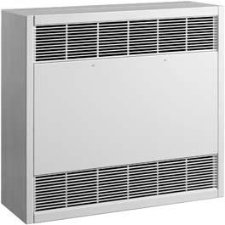


Watts (1) |  | Volts | Ph | Total  Amps (2) |  | CFM |  | Approx. Air Temperature Rise ºF (ºC) | Heater Length  In. (mm) | Weight  lb (kg) | Catalog  Number
Max. | Min. | Volts | Ph | Max | Min | Max. | Min.
2000 | 1333 | 208 | 1 | 11.0 | 7.8 | 250 | 200 | 26 (14) | 28 (711) | 115 (52) | HX-922U02000C¶§
2000 | 1333 | 208 | 3 | 7.0 | 5.1 | 250 | 200 | 26 (14) | 28 (711) | 115 (52) | HX-922U02000D¶§
2000 | 1333 | 240 | 1 | 9.7 | 7.0 | 250 | 200 | 26 (14) | 28 (711) | 115 (52) | HX-922U02000J¶§
2000 | 1333 | 240 | 3 | 6.2 | 4.6 | 250 | 200 | 26 (14) | 28 (711) | 115 (52) | HX-922U02000K¶§
2000 | 1333 | 277 | 1 | 8.6 | 6.2 | 250 | 200 | 26 (14) | 28 (711) | 115 (52) | HX-922U02000N¶§
2000 | 1333 | 480 | 3 | 3.8 | 3.0 | 250 | 200 | 26 (14) | 28 (711) | 115 (52) | HX-922U02000U¶§
3000 | 1000 | 208 | 1 | 15.8 | 6.2 | 250 | 200 | 38 (21) | 28 (711) | 115 (52) | HX-922U03000C¶§
3000 | 1000 | 208 | 3 | 9.7 | 4.2 | 250 | 200 | 38 (21) | 28 (711) | 115 (52) | HX-922U03000D¶§
3000 | 1000 | 240 | 1 | 13.9 | 5.6 | 250 | 200 | 38 (21) | 28 (711) | 115 (52) | HX-922U03000J¶§
3000 | 1000 | 240 | 3 | 8.6 | 3.8 | 250 | 200 | 38 (21) | 28 (711) | 115 (52) | HX-922U03000K¶§
3000 | 1000 | 277 | 1 | 12.2 | 5.0 | 250 | 200 | 38 (21) | 28 (711) | 115 (52) | HX-922U03000N¶§
3000 | 1000 | 480 | 3 | 5.0 | 2.6 | 250 | 200 | 38 (21) | 28 (711) | 115 (52) | HX-922U03000U¶§
4000 | 2667 | 208 | 1 | 20.6 | 14.2 | 250 | 200 | 51 (28) | 28 (711) | 115 (52) | HX-922U04000C¶§
4000 | 2667 | 208 | 3 | 12.5 | 8.8 | 250 | 200 | 51 (28) | 28 (711) | 115 (52) | HX-922U04000D¶§
4000 | 2667 | 240 | 1 | 18.1 | 12.5 | 250 | 200 | 51 (28) | 28 (711) | 115 (52) | HX-922U04000J¶§
4000 | 2667 | 240 | 3 | 11.0 | 7.8 | 250 | 200 | 51 (28) | 28 (711) | 115 (52) | HX-922U04000K¶§
4000 | 2667 | 277 | 1 | 15.8 | 11.0 | 250 | 200 | 51 (28) | 28 (711) | 115 (52) | HX-922U04000N¶§
4000 | 2667 | 480 | 3 | 6.2 | 4.6 | 250 | 200 | 51 (28) | 28 (711) | 115 (52) | HX-922U04000U¶§
5000 | 3333 | 208 | 1 | 25.4 | 17.4 | 250 | 200 | 64 (36) | 28 (711) | 115 (52) | HX-922U05000C¶§
5000 | 3333 | 208 | 3 | 15.3 | 10.7 | 250 | 200 | 64 (36) | 28 (711) | 115 (52) | HX-922U05000D¶§
5000 | 3333 | 240 | 1 | 22.2 | 15.3 | 250 | 200 | 64 (36) | 28 (711) | 115 (52) | HX-922U05000J¶§
5000 | 3333 | 240 | 3 | 13.4 | 9.4 | 250 | 200 | 64 (36) | 28 (711) | 115 (52) | HX-922U05000K¶§
5000 | 3333 | 277 | 1 | 19.5 | 13.4 | 250 | 200 | 64 (36) | 28 (711) | 115 (52) | HX-922U05000N¶§
5000 | 3333 | 480 | 3 | 7.4 | 5.4 | 250 | 200 | 64 (36) | 28 (711) | 115 (52) | HX-922U05000U¶§
6000 | 4000 | 208 | 1 | 30.2 | 20.6 | 250 | 200 | 77 (43) | 28 (711) | 115 (52) | HX-922U06000C¶§
6000 | 4000 | 208 | 3 | 18.1 | 12.5 | 250 | 200 | 77 (43) | 28 (711) | 115 (52) | HX-922U06000D¶§
6000 | 4000 | 240 | 1 | 26.4 | 18.1 | 250 | 200 | 77 (43) | 28 (711) | 115 (52) | HX-922U06000J¶§
6000 | 4000 | 240 | 3 | 15.8 | 11.0 | 250 | 200 | 77 (43) | 28 (711) | 115 (52) | HX-922U06000K¶§
6000 | 4000 | 277 | 1 | 23.1 | 15.8 | 250 | 200 | 77 (43) | 28 (711) | 115 (52) | HX-922U06000N¶§
6000 | 4000 | 480 | 3 | 8.6 | 6.2 | 250 | 200 | 77 (43) | 28 (711) | 115 (52) | HX-922U06000U¶§
8000 | 4000 | 208 | 1 | 41.3 | 22.0 | 500 | 400 | 51 (28) | 48 (1219) | 146 (66) | HX-922U08000C¶§
8000 | 4000 | 208 | 3 | 25.0 | 13.9 | 500 | 400 | 51 (28) | 48 (1219) | 146 (66) | HX-922U08000D¶§
8000 | 4000 | 240 | 1 | 36.1 | 19.5 | 500 | 400 | 51 (28) | 48 (1219) | 146 (66) | HX-922U08000J¶§
8000 | 4000 | 240 | 3 | 22.1 | 12.4 | 500 | 400 | 51 (28) | 48 (1219) | 146 (66) | HX-922U08000K¶§
8000 | 4000 | 277 | 1 | 31.7 | 17.2 | 500 | 400 | 51 (28) | 48 (1219) | 146 (66) | HX-922U08000N¶§
8000 | 4000 | 480 | 3 | 12.4 | 7.6 | 500 | 400 | 51 (28) | 48 (1219) | 146 (66) | HX-922U08000U¶§
10000 | 5000 | 208 | 1 | 50.9 | 26.8 | 500 | 400 | 64 (36) | 48 (1219) | 146 (66) | HX-922U10000C¶§
10000 | 5000 | 208 | 3 | 30.6 | 16.7 | 500 | 400 | 64 (36) | 48 (1219) | 146 (66) | HX-922U10000D¶§
10000 | 5000 | 240 | 1 | 44.5 | 23.6 | 500 | 400 | 64 (36) | 48 (1219) | 146 (66) | HX-922U10000J¶§
10000 | 5000 | 240 | 3 | 26.9 | 14.8 | 500 | 400 | 64 (36) | 48 (1219) | 146 (66) | HX-922U10000K¶§
10000 | 5000 | 277 | 1 | 38.9 | 20.9 | 500 | 400 | 64 (36) | 48 (1219) | 146 (66) | HX-922U10000N¶§
10000 | 5000 | 480 | 3 | 14.8 | 8.8 | 500 | 400 | 64 (36) | 48 (1219) | 146 (66) | HX-922U10000U¶§
12000 | 6000 | 208 | 1 | 60.5 | 31.6 | 500 | 400 | 77 (43) | 48 (1219) | 146 (66) | HX-922U12000C¶§
12000 | 6000 | 208 | 3 | 36.1 | 19.5 | 500 | 400 | 77 (43) | 48 (1219) | 146 (66) | HX-922U12000D¶§
12000 | 6000 | 240 | 1 | 52.8 | 27.8 | 500 | 400 | 77 (43) | 48 (1219) | 146 (66) | HX-922U12000J¶§
12000 | 6000 | 240 | 3 | 31.7 | 17.3 | 500 | 400 | 77 (43) | 48 (1219) | 146 (66) | HX-922U12000K¶§
12000 | 6000 | 277 | 1 | 46.1 | 24.5 | 500 | 400 | 77 (43) | 48 (1219) | 146 (66) | HX-922U12000N¶§
12000 | 6000 | 480 | 3 | 17.3 | 10.0 | 500 | 400 | 77 (43) | 48 (1219) | 146 (66) | HX-922U12000U¶§
15000 | 10000 | 208 | 1 | 76.3 | 52.3 | 750 | 600 | 63 (35) | 66 (1677) | 210 (96) | HX-922U15000C¶§
15000 | 10000 | 208 | 3 | 45.9 | 32.0 | 750 | 600 | 63 (35) | 66 (1677) | 210 (96) | HX-922U15000D¶§
15000 | 10000 | 240 | 1 | 66.7 | 45.9 | 750 | 600 | 63 (35) | 66 (1677) | 210 (96) | HX-922U15000J¶§
15000 | 10000 | 240 | 3 | 40.3 | 28.3 | 750 | 600 | 63 (35) | 66 (1677) | 210 (96) | HX-922U15000K¶§
15000 | 10000 | 480 | 3 | 22.2 | 16.2 | 750 | 600 | 63 (35) | 66 (1677) | 210 (96) | HX-922U15000U¶§
18000 | 12000 | 208 | 1 | 90.7 | 61.9 | 750 | 600 | 77 (43) | 66 (1677) | 210 (96) | HX-922U18000C¶§
18000 | 12000 | 208 | 3 | 54.2 | 37.5 | 750 | 600 | 77 (43) | 66 (1677) | 210 (96) | HX-922U18000D¶§
18000 | 12000 | 240 | 1 | 79.2 | 54.2 | 750 | 600 | 77 (43) | 66 (1677) | 210 (96) | HX-922U18000J¶§
18000 | 12000 | 240 | 3 | 47.5 | 33.1 | 750 | 600 | 77 (43) | 66 (1677) | 210 (96) | HX-922U18000K¶§
18000 | 12000 | 480 | 3 | 25.9 | 18.6 | 750 | 600 | 77 (43) | 66 (1677) | 210 (96) | HX-922U18000U¶§
20000 | 13333 | 208 | 1 | 101.8 | 69.7 | 1000 | 800 | 64 (36) | 80 (2032) | 240 (109) | HX-922U20000C¶§
20000 | 13333 | 208 | 3 | 61.1 | 42.6 | 1000 | 800 | 64 (36) | 80 (2032) | 240 (109) | HX-922U20000D¶§
20000 | 13333 | 240 | 1 | 88.9 | 61.2 | 1000 | 800 | 64 (36) | 80 (2032) | 240 (109) | HX-922U20000J¶§
20000 | 13333 | 240 | 3 | 53.7 | 37.7 | 1000 | 800 | 64 (36) | 80 (2032) | 240 (109) | HX-922U20000K¶§
20000 | 13333 | 480 | 3 | 29.7 | 21.7 | 1000 | 800 | 64 (36) | 80 (2032) | 240 (109) | HX-922U20000U¶§
24000 | 16000 | 208 | 3 | 72.2 | 50.1 | 1000 | 800 | 77 (43) | 80 (2032) | 240 (109) | HX-922U24000D¶§
24000 | 16000 | 240 | 1 | 105.6 | 72.3 | 1000 | 800 | 77 (43) | 80 (2032) | 240 (109) | HX-922U24000J¶§
24000 | 16000 | 240 | 3 | 63.3 | 44.1 | 1000 | 800 | 77 (43) | 80 (2032) | 240 (109) | HX-922U24000K¶§
24000 | 16000 | 480 | 3 | 34.5 | 24.9 | 1000 | 800 | 77 (43) | 80 (2032) | 240 (109) | HX-922U24000U¶§
(1) To obtain the minimum ratings, it is necessary to add the optional "N1" two-speed motor with high/low switch for manual operation or option "N2" two-speed motor with high/low relay-24 Volt. The "N2" can be connected to a remote two-stage, wall-mounted thermostat or field-furnished low voltage device for maximum/minimum control.
(2) Total Amps = Heating element amps and motor amps.
Other voltages available. Consult factory.
¶Standard colors - Add W for white finish or A for almond finish to the end of catalog number.
Special or custom colors available.
§Specify mounting configuration letter when ordering (see page 4).

Factory Built-in Options

Code | Description
A1 | Fresh Air Inlet (1)
A2 | Power Operated Fresh Air Inlet (1)
D1 | Disconnect Switch 600V, Three-pole, 40 Amp
D2 | Disconnect Switch 600V, Three-pole, 80 Amp
G | Fusing
M | Manual Reset
N1 | 2-Speed Motor w/High-Low Switch (2)
N2 | 2-Speed Motor w/High-Low Relay-24V(1)(2)(3)
R1 | 24V Relay
R2 | 24V Relay with Transformer
S | Smooth Finish on Heater Back  Heater Length - In. (mm) | 28 (711)
S | Smooth Finish on Heater Back  Heater Length - In. (mm) | 48 (1219)
S | Smooth Finish on Heater Back  Heater Length - In. (mm) | 66 (1677)
S | Smooth Finish on Heater Back  Heater Length - In. (mm) | 80 (2032)
S1 | On/Auto Fan Relay-24V
S2 | 24V On/Standby Heating Relay with Transformer
S3 | On/Auto Fan Switch
S4 | On/Standby Heating Switch
T1 | Tamperproof Thermostat, Single-pole, Single Stage
T7 | Tamperproof Thermostat, Two-Stage (4)

(1) Do not install built-in thermostat with these options.
(2) To obtain the minimum ratings, it is necessary to add the optional "N1" two-speed motor with high/low switch for manual operation or option "N2" two-speed motor with high/low relay-24 Volt. The "N2" can be connected to a remote two-stage, wall-mounted thermostat or field-furnished low voltage device for maximum/minimum control.
(3) Option N2 is required for two-stage remote thermostat operation.
(4) When choosing option T7; A1, A2, N1, N2, R1, R2 & T1 are unavailable.
Field-Installed Options
(shipped loose for field Installation into heater)

Catalog  Number | Description | Heater  Length  In. (mm)
922-124530¶ | Sub Base | 28 (711)
922-124531¶ | Sub Base | 48 (1219)
922-124532¶ | Sub Base | 66 (1676)
992-124533¶ | Sub Base | 80 (2032)
922-124534¶ | Recessed Trim Kit | 28 (711)
922-124535¶ | Recessed Trim Kit | 48 (1219)
922-124536¶ | Recessed Trim Kit | 66 (1676)
922-124537¶ | Recessed Trim Kit | 80 (2032)
922-124538P | Permanent/Washable  Air Filters  (Wall Installation Only) | 28 (711)
922-124539P | Permanent/Washable  Air Filters  (Wall Installation Only) | 48 (1219)
922-124540P | Permanent/Washable  Air Filters  (Wall Installation Only) | 66 (1676)
922-124541P | Permanent/Washable  Air Filters  (Wall Installation Only) | 80 (2032)
922-124538 | Replaceable Throwaway  Air Filters  (Wall Installation Only) | 28 (711)
922-124539 | Replaceable Throwaway  Air Filters  (Wall Installation Only) | 48 (1219)
922-124540 | Replaceable Throwaway  Air Filters  (Wall Installation Only) | 66 (1676)
922-124541 | Replaceable Throwaway  Air Filters  (Wall Installation Only) | 80 (2032)
922-218265 ¶ | Smooth Finish on Heater  Back Kit  Heater Length  In (mm) | 28 (711)
922-218266 ¶ | Smooth Finish on Heater  Back Kit  Heater Length  In (mm) | 48 (1219)
922-218267 ¶ | Smooth Finish on Heater  Back Kit  Heater Length  In (mm) | 66 (1676)
922-218268 ¶ | Smooth Finish on Heater  Back Kit  Heater Length  In (mm) | 80 (2032)
922-274750 | Tamperproof single-pole thermostat kit

¶ Standard colors - Add W for white finish or A for almond finish to end of catalog number.

HOW TO ORDER

9XXXXXXXXX A D -EFG

Add all desired factory built-in options

922 Series Cabinet Unit Heaters only, include the mounting configuration:
A1, A2, A3, B1, B2, B3, C1, C2, C3, or D1, D2, D3 (See below)

Add the finish color desired:
A = Almond
Standard Colors
W = White
O = Other (specify) - Custom Color Selection
Special Colors available, consult factory.

Select the catalog number for the heater

D1 Mounting Standard if not specified on order.

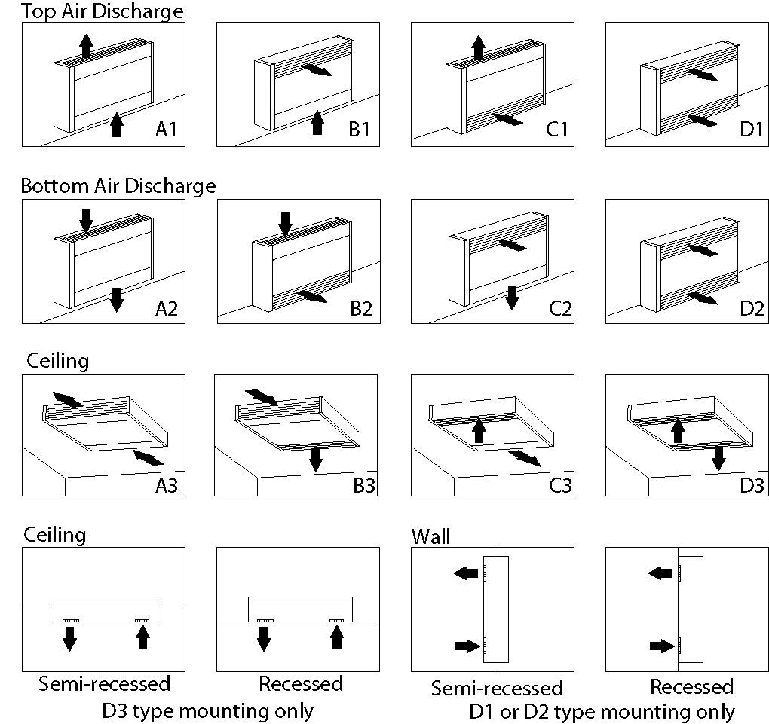

Maximum recommended installation height: 10 feet

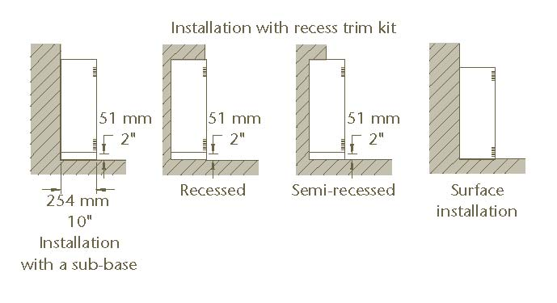

Architect’s and Engineering Specifications

The specified heating equipment shall include an electric, fan-forced air cabinet unit heater suitable for space heating as manufactured by HEATREX. The cabinet unit heater shall be designed for mounting in any position including on-end, fully recessed, semi-recessed or surface mounted. Heaters shall be third party approved to UL standard 2021. CSA-US or equivalent is acceptable.

Cabinet shall be of heavy-duty, 18 Ga. minimum cold rolled steel. The heater front cover shall be hinged for simplified maintenance. The cover shall be secured to the cabinet by a maximum of two screws. The grille shall be an extruded aluminum bar that prevents insertion of foreign objects. Inlet and outlet grilles can be field changeable for 12 air inlet and outlet combinations. Cabinet finish shall be an epoxy/ polyester powder paint in either white or almond. Optional – Color by architect.
Heating Elements shall be of finned tubular type and located directly downstream of the blower discharge air for uniform heating.
Thermal Cutouts shall be built-in to every heater for temperature protection. The automatic reset thermal cutouts shall directly interrupt power to the elements without the use of relays. Optional – Manual reset thermal cutout for back-up temperature protection.
Motor and Blower Assembly shall be a squirrel cage fan that is beltless. The fans shall be powered by motors with permanently lubricated ball bearing for years of trouble free service. The blower wheel shall be mounted directly on the motor shaft, which reduces noise level. The decibel ratings of the assembly shall not exceed 50 dBA. The motor shall be a two speed, 1/15 HP with automatic reset overload protection.
Air Filters are optional and shall be located ahead of the motor assembly and blower to assure clean air circulation. Either replaceable (throw-away) or washable (permanent) type filters must be specified.
Temperature Control includes an optional built-in, single pole, tamperproof thermostat. A 24 Volt relay may be substituted for the on/off switch or thermostat options.
Other Control Options include On/Off switch, Hi/Low switch for 2-speed motor and an On/Auto fan switch.
Other Optional Features include a power operated fresh air inlet, smooth finish back-mounting plate when back of heateris visible, recess trim for non-surface mounted units, sub base for floor mounted units and fusing when heater load is below 48 Amps.
Rough In Dimensions – Recess mounting only: Heater Length + 1” wide x 27” x 12” deep.

