
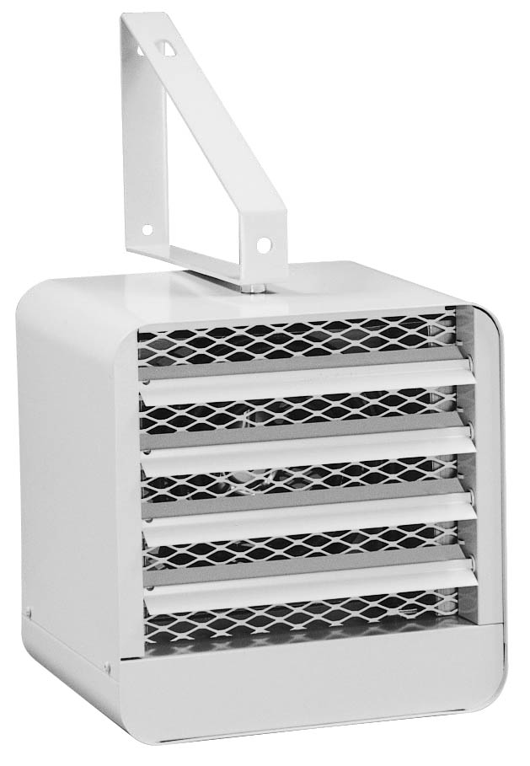
Adjustable thermostat is included.
Watts | Volts | Phase | Total  Amps (1) | CFM | Approximate  Air Temperature  Rise ºF (ºC) | Weight  lb (kg) | Catalog  Number
2000/1500 | 240/208 | 1 | 8.7/7.6 | 300 | 21/16 (12/9) | 20 (9) | HX-924U02000VA
3000/2250 | 240/208 | 1 | 12.9/11.2 | 300 | 32/24 (18/13) | 20 (9) | HX-924U03000VA
5000/3750 | 240/208 | 1 | 21.2/18.4 | 300 | 53/40 (29/22) | 20 (9) | HX-924U05000VA
(1) Total Amps = Heating element amps and motor amps.
Only available with almond finish.
All units include both ceiling and wall mounting brackets.

Architect’s and Engineer’s Specifications
The specified heating equipment shall include an electric, fan-forced air unit heater suitable for space heating as manufactured by HEATREX. The unit heater shall be designed for mounting in the horizontal position. Heaters shall be third party approved to CSA standards. Reference: UL standard 2021.

Heating Housing shall be made from 20 gauge steel. Individual adjustable louvers with 30 degree downward stops shall be furnished to provide the desired control of discharge air. Cabinet finish shall be an almond epoxy/polyester powder paint. Mounting brackets designed for either ceiling or wall mounting shall be furnished as shown. Housing shall include an outlet protective screen. Screen shall prohibit debris from reaching the element compartment.
Heater Elements shall be stainless steel and located downstream of the motor and fan blade for uniform heating and to eliminate hot spots.
Fan and Motor shall be permanently lubricated and totally enclosed. Fan and motor shall be located upstream of heating elements. This location allows the motor to run cooler and have a longer life expectancy. The motor shall be thermally protected. Fan shall operate at 300 CFM minimum.
Thermal Cutoutshall be built-in to every heater and wired for instantaneous deenergizing of the heating elements.
Thermostat shall be built-in to heater and adjustable from 50-109 ºF through main control compartment.

