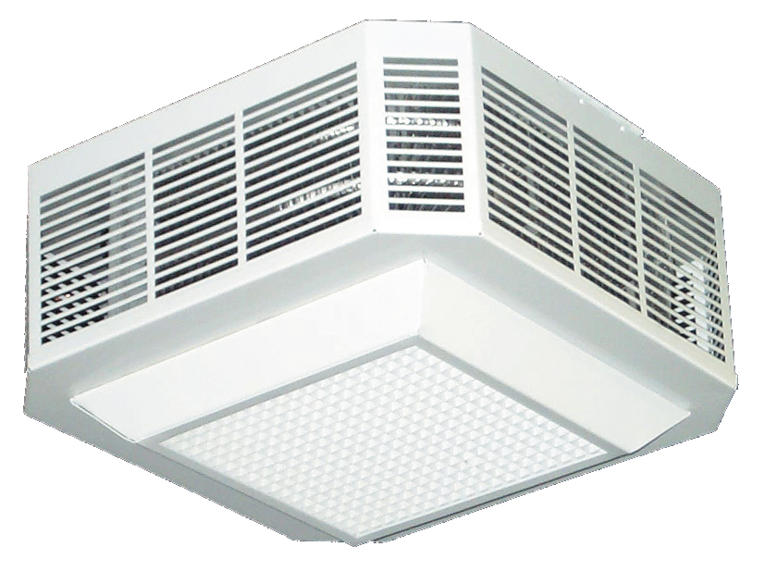

Surface Mounting
Watts | Volts | Total  Amps (1) | CFM | Approximate Air  Temperature  Rise ºF (ºC) | Weight  lb (kg) | Catalog  Number
2000 | 208/1 | 10.3 | 450 | 14 (8) | 25 (11.3) | HX-936U02000C¶
2000 | 208/3 | 6.3 | 450 | 14 (8) | 25 (11.3) | HX-936U02000D¶
2000 | 240/1 | 9.0 | 450 | 14 (8) | 25 (11.3) | HX-936U02000J¶
2000 | 240/3 | 5.5 | 450 | 14 (8) | 25 (11.3) | HX-936U02000K¶
2000 | 277/1 | 7.9 | 450 | 14 (8) | 25 (11.3) | HX-936U02000N¶
2000 | 480/1 | 4.9 | 450 | 14 (8) | 25 (11.3) | HX-936U02000T¶
2000 | 480/3 | 3.1 | 450 | 14 (8) | 25 (11.3) | HX-936U02000U¶
3000 | 208/1 | 15.1 | 450 | 21 (12) | 25 (11.3) | HX-936U03000C¶
3000 | 208/3 | 9.0 | 450 | 21 (12) | 25 (11.3) | HX-936U03000D¶
3000 | 240/1 | 13.2 | 450 | 21 (12) | 25 (11.3) | HX-936U03000J¶
3000 | 240/3 | 7.9 | 450 | 21 (12) | 25 (11.3) | HX-936U03000K¶
3000 | 277/1 | 11.5 | 450 | 21 (12) | 25 (11.3) | HX-936U03000N¶
3000 | 480/1 | 7.0 | 450 | 21 (12) | 25 (11.3) | HX-936U03000T¶
3000 | 480/3 | 4.3 | 450 | 21 (12) | 25 (11.3) | HX-936U03000U¶
4000 | 208/1 | 19.9 | 450 | 28 (16) | 25 (11.3) | HX-936U04000C¶
4000 | 208/3 | 11.8 | 450 | 28 (16) | 25 (11.3) | HX-936U04000D¶
4000 | 240/1 | 17.4 | 450 | 28 (16) | 25 (11.3) | HX-936U04000J¶
4000 | 240/3 | 10.3 | 450 | 28 (16) | 25 (11.3) | HX-936U04000K¶
4000 | 277/1 | 15.1 | 450 | 28 (16) | 25 (11.3) | HX-936U04000N¶
4000 | 480/1 | 9.0 | 450 | 28 (16) | 25 (11.3) | HX-936U04000T¶
4000 | 480/3 | 5.5 | 450 | 28 (16) | 25 (11.3) | HX-936U04000U¶
5000 | 208/1 | 24.7 | 450 | 35 (19) | 25 (11.3) | HX-936U05000C¶
5000 | 208/3 | 14.6 | 450 | 35 (19) | 25 (11.3) | HX-936U05000D¶
5000 | 240/1 | 21.5 | 450 | 35 (19) | 25 (11.3) | HX-936U05000J¶
5000 | 240/3 | 12.7 | 450 | 35 (19) | 25 (11.3) | HX-936U05000K¶
5000 | 277/1 | 18.8 | 450 | 35 (19) | 25 (11.3) | HX-936U05000N¶
5000 | 480/1 | 11.1 | 450 | 35 (19) | 25 (11.3) | HX-936U05000T¶
5000 | 480/3 | 6.7 | 450 | 35 (19) | 25 (11.3) | HX-936U05000U¶
7500 | 208/1 | 36.8 | 700 | 34 (19) | 34 (15.4) | HX-936U07500C¶
7500 | 208/3 | 21.5 | 700 | 34 (19) | 34 (15.4) | HX-936U07500D¶
7500 | 240/1 | 32.0 | 700 | 34 (19) | 34 (15.4) | HX-936U07500J¶
7500 | 240/3 | 18.7 | 700 | 34 (19) | 34 (15.4) | HX-936U07500K¶
7500 | 277/1 | 27.8 | 700 | 34 (19) | 34 (15.4) | HX-936U07500N¶
7500 | 480/1 | 16.3 | 700 | 34 (19) | 34 (15.4) | HX-936U07500T¶
7500 | 480/3 | 9.7 | 700 | 34 (19) | 34 (15.4) | HX-936U07500U¶
9900 | 208/1 | 48.0 | 700 | 46 (26) | 34 (15.4) | HX-936U09900C¶
9900 | 208/3 | 28.0 | 700 | 46 (26) | 34 (15.4) | HX-936U09900D¶
10000 | 240/1 | 42.4 | 700 | 46 (26) | 34 (15.4) | HX-936U10000J¶
10000 | 240/3 | 24.8 | 700 | 46 (26) | 34 (15.4) | HX-936U10000K¶
10000 | 277/1 | 36.8 | 700 | 46 (26) | 34 (15.4) | HX-936U10000N¶
10000 | 480/1 | 21.5 | 700 | 46 (26) | 34 (15.4) | HX-936U10000T¶
10000 | 480/3 | 12.7 | 700 | 46 (26) | 34 (15.4) | HX-936U10000U¶
(1) Total Amps = Heating element amps and motor amps.
¶ Add W to end of catalog number for white finish or add A for almond finish.

Factory Built-in Options
Code | Description
D1 | Disconnect Switch 600V, Three-pole, 40 Amp
D2 | Disconnect Switch 600V, Three-pole, 80 Amp
D3 | Disconnect Switch 277V, Double-pole, 20 Amp
R1 | 24V Control Relay
R2 | 24V Control Relay with Transformer
S3 | Summer Fan Switch and Pilot Light
S5 | Summer Fan 24V Relay for Remote Switching and Pilot Light (Switch not included)
S6 | Summer Fan 240V Relay for Remote Switching and Pilot Light (Switch not included)
T1 | Tamperproof Thermostat
X | 120V Control, fused secondary and grounded

Field-Installed Options
(shipped loose for field Installation into heater)
Catalog  Number | Description
936-158478¶ | Tamperproof thermostat kit
936-158479¶ | Adaptor for T-Bar for CDI Surface Mounting 2,000 through 5,000 Watt Heaters ONLY
936-218269 | 24 Volt Control Relay Kit
¶ Add W to end of catalog number for white finish or add A for almond finish.

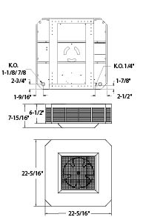
CDI
2,000-5,000 Watt
Surface Mounting
CDI
7,500-10,000 Watt
Surface Mounting

CDI
2,000-5,000 Watt
Surface Mounting

CDI Surface Mounting
7,500-10,000 Watt Heaters

Architect’s and Engineer’s Specifications

- Electric fan-forced ceiling heaters shall be by HEATREX, construction and options as shown below. Heaters shall be CSA _{US} Certified, for the wattage, voltage, CFM and size as specified in the schedule.

- Heater shall be fully assembled with all standard controls specified mounted into the heater. Heater shall be designed for surface or T-Bar mounting; see schedule for mounting requirements.

- Heater shall be a side inlet draw-through design with downward discharge to provide uniform circulation within the space.

- Heaters shall use non-glowing tubular elements with aluminum fins to provide efficient heat transfer. High quality alloy resistance element wire shall be centered in a stainless steel sheath and surrounded by magnesium oxide. Aluminum fins shall be mechanically attached to the length of the element to increase the heat transfer area. Heating elements shall be positioned to cover the entire air intake on three sides to ensure uniform heating of the discharge air.

- Heater box shall be constructed from 20 gauge galvanized steel. Front panel shall be heavy 20 gauge galvanized steel and shall be finished with baked-on powder paint.

- Heater shall be furnished with: A totally enclosed, lifetime-lubricated ball bearing motor with internal overload protection; fan control to continue fan operation until the heated air has been discharged; automatic reset thermal cutout to de-energize the heater in the event of overheating and reset once the temperature has reached normal operating temperature; built-in safety contactor when controls cannot be load carrying; power terminal blocks marked for field wiring.

