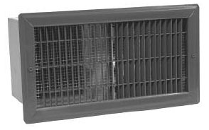
Watts | Volts | Total  Amps (1) | CFM | Approximate Air  Temperature  Rise ºF (ºC) | Weight  lb (kg) | Catalog  Number
500 | 120 | 4.6 | 80 | 20 (11) | 16 (7.3) | HX-939U00500B¶
1000 | 120 | 8.8 | 80 | 40 (22) | 16 (7.3) | HX-939U01000B¶
1500 | 120 | 13.0 | 80 | 60 (33) | 16 (7.3) | HX-939U01500B¶
1000/750 | 240/208 | 4.6/4.1 | 80 | 40/30 (22/17) | 16 (7.3) | HX-939U01000V¶
1500/1125 | 240/208 | 6.7/5.9 | 80 | 60/45 (33/25) | 16 (7.3) | HX-939U01500V¶
(1) Total Amps = Heating element amps and motor amps.
¶ Add W to end of catalog number for white finish, A for almond, or BZ for bronze.

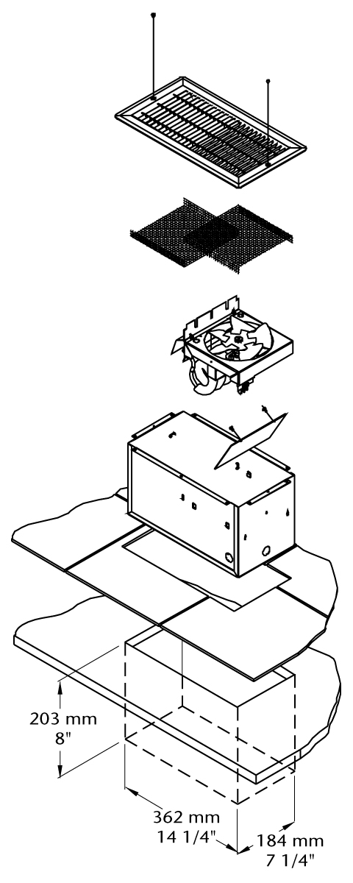

Architect’s and Engineer’s Specifications
The specified heating equipment shall include an electric, fan-forced air unit heater suitable for space heating as manufactured by HEATREX. The light duty unit heater shall be designed for mounting in the horizontal position. Heaters shall be third party approved UL standard 2021 CSA-US or equivalent is acceptable.

Heating Elements - Steel finned tubular elements provide durability.
Housing - Heavy welded 20-gauge steel housing.
Outlet Grille - The 14-gauge steel grille has an epoxy-polyester powder paint finish. Standard grille colors include bronze, white or almond.
Built-in Controls - Manual reset thermal cutout prevents overheating.
Fan Motor - Quiet, factory-lubricated fan motor operates at 39.5 dBA with 80 CFM.
Installation Requirements - Floor heaters should be installed a minimum of six inches from adjacent walls.
Rough in Dimentions – All heaters: 14-3/8” wide x 7-7/16” high x 8” deep.


