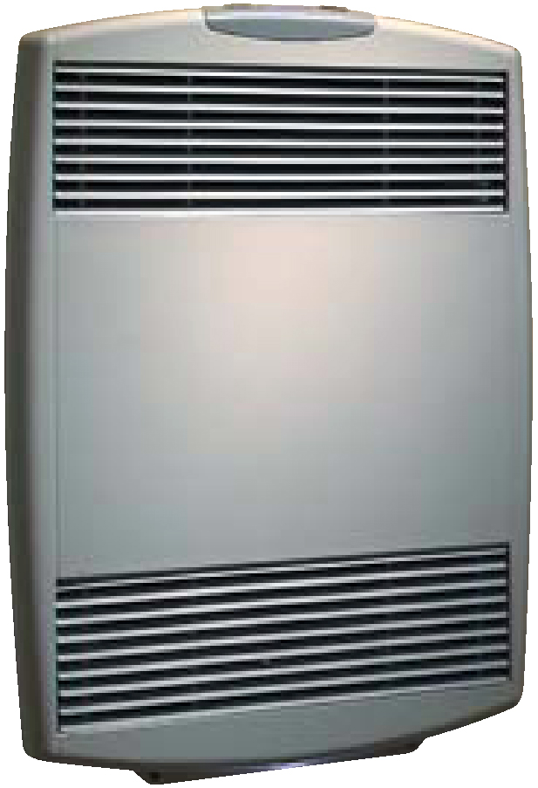

Built-in digital thermostat with timer is included.
Watts | Volts | Amps | Weight  lb (kg) | Catalog  Number
1500 | 120 | 12.5 | 22.8 (10.3) | HX-940U01500B¶
2000 | 240 | 8.3 | 22.8 (10.3) | HX-940U02000J¶
¶Standard colors – Add W for white finish or A for almond finish to the end of catalog number.

Factory Built-in Options
Code | Description
D3 | Disconnect Switch, 277V, Double-pole, 20 Amp

Field-Installed Options
Catalog  Number | Description
940-213895¶ | Cast Aluminum Surface Mounting Box
¶Standard colors – Add W for white finish or A for almond finish to the end of catalog number.

Architect’s and Engineer’s Specifications

Heating Elements – Instant heat nickel-chrome coil resistant wire element.
Outlet Grille – Heavy cast aluminum front cover with steel bar inlet and outlet grilles has a polyester powder paint finish available in white or almond.
Built-in Controls – Digital display electronic thermostat with timer, automatic reset thermal cutout, temperature sensor and LED night light with on-off switch.
Fan motor – Whisper-quiet squirrel-cage fan with factory-lubricated motor.
Installation Requirements –Maintain a minimum of 4-inches (102 mm) clearance below heater, 1-inch (25 mm) to adjacent walls and 48-inches (1219 mm) in front of heater.
Rough In Dimensions – All heaters: 18-5/8” wide x 13-3/8” high x 2-3/4” deep.

