EXPLOSION-PROOF DUCT HEATERS

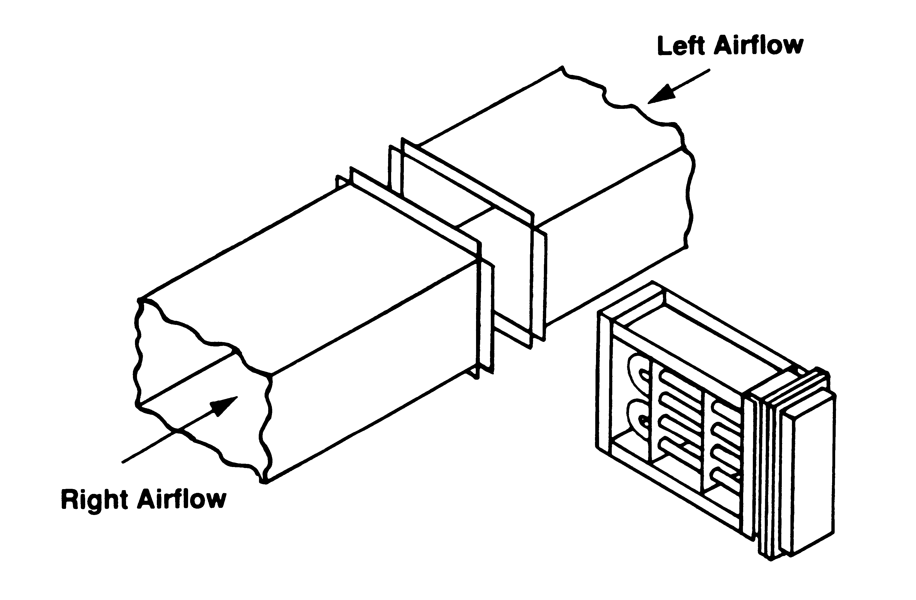
Figure 1 - Standard Flanged Heater Installation

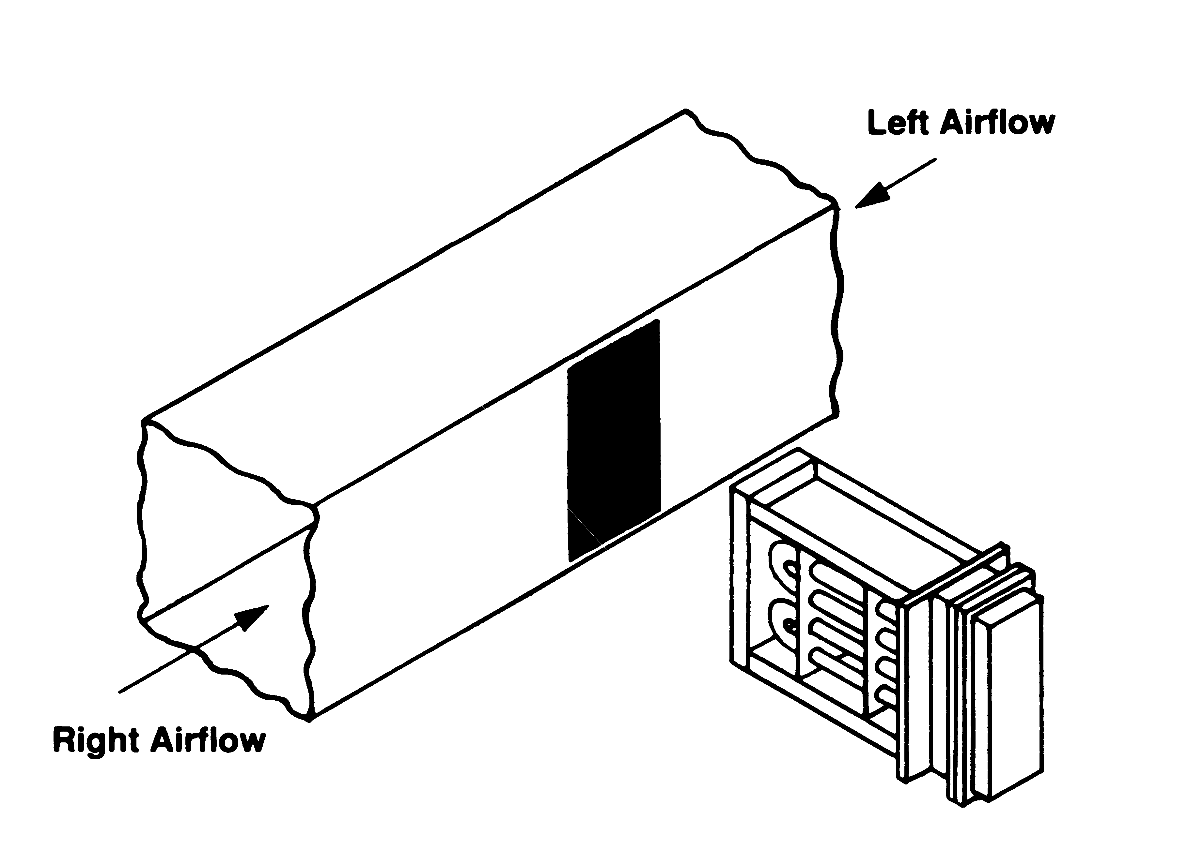
Figure 2 - Optional Slip-in Heater Installation
(Not recommended for most applications)


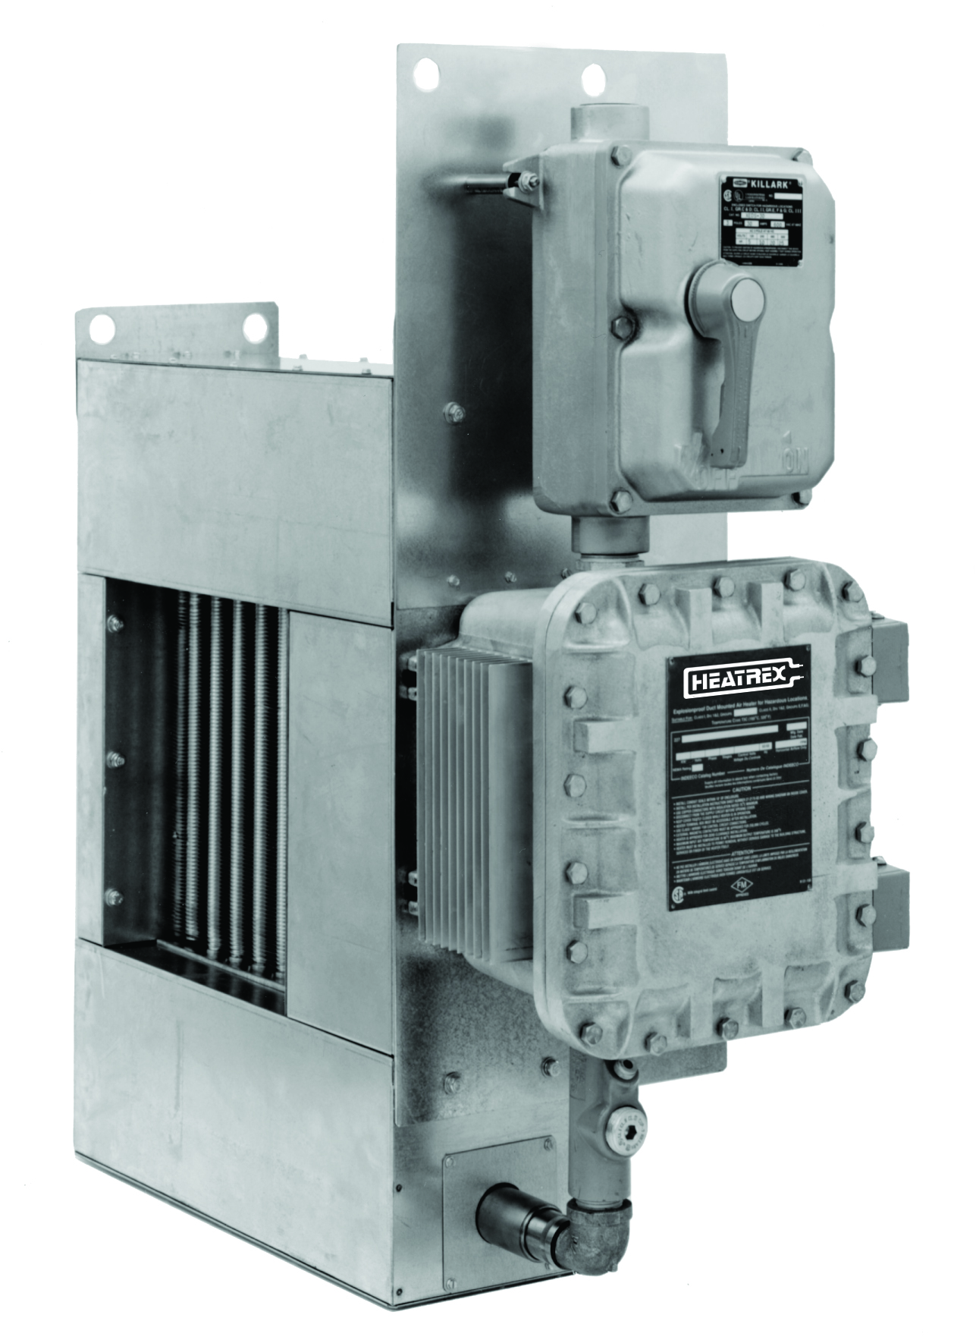
Figure 3 – 227 Series Explosion-proof Duct Heater

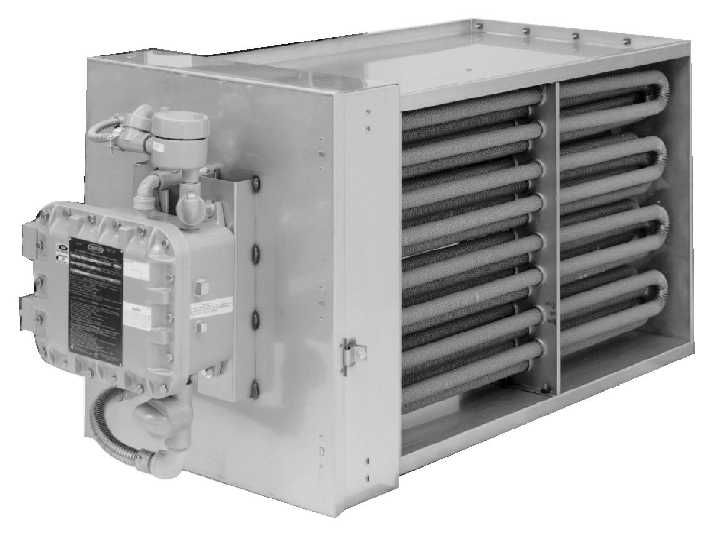
Figure 4 – 220 Series Explosion-proof Duct Heater

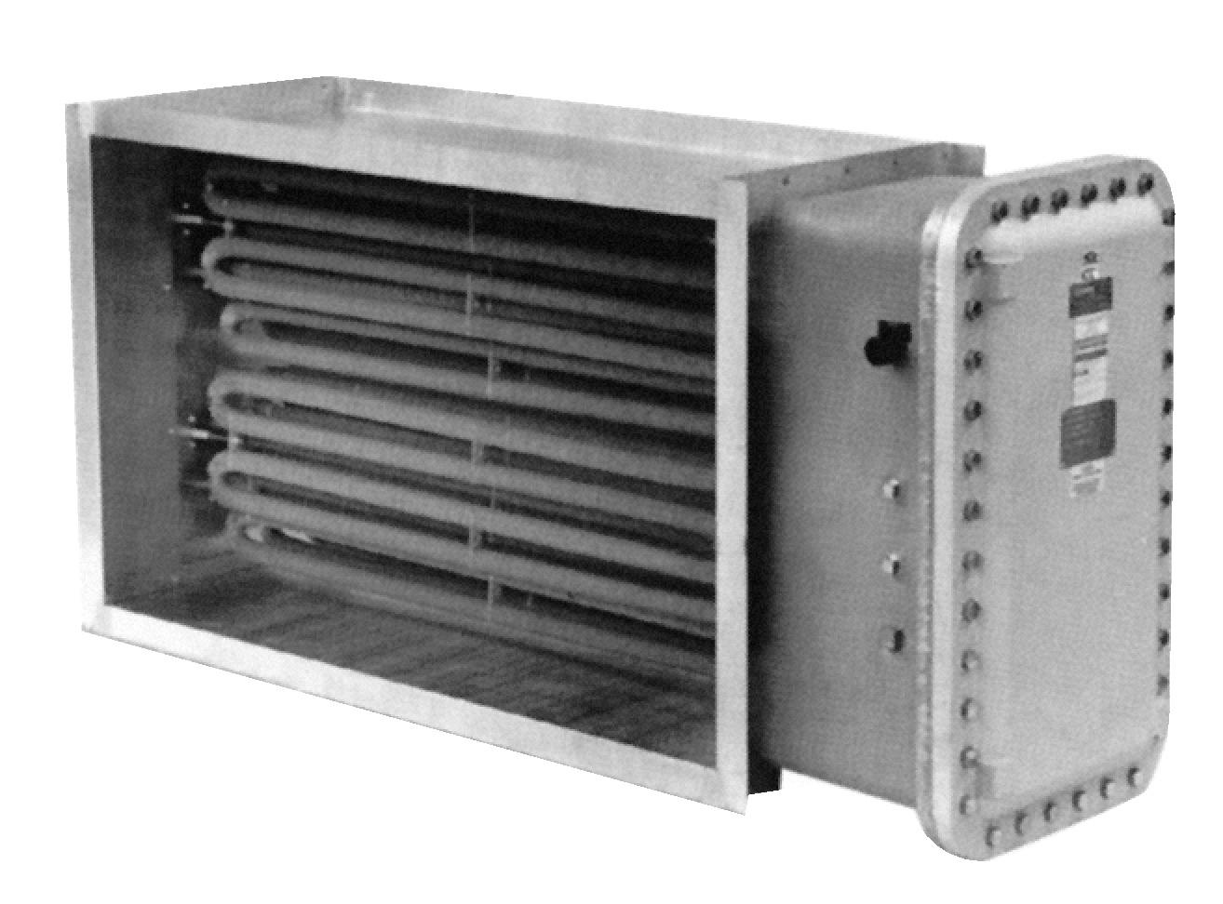
Figure 5 - Custom Explosion-proof Duct Heater
No Agency Approvals

HOW TO ORDER

1. Construction Type (check one):
Standard Flanged | Optional Slip-in
2. Electrical Ratings:
Line Voltage | Phase
KW | Control Voltage
3. Inside Duct Dimensions (Inches):
Width | Height
4. Airflow Direction (check one):
Right | Up
Left | Down
5. Minimum Airflow Through Heater:
Ft/Sec | CFM
6. Maximum Inlet Air Temperature (80° F Standard):
°F
7. Classification of Hazardous Area:
Class
Group
Ignition Temperature °F
NEC I.D. Code No.
8. Temperature Control (check one):
SCR Control | ON/OFF Control
Specify Input Signal
Standard 2200 ohm | Number of Steps
(from Heatrex thermostat) | (Step Controller required
Optional | For more then 2 steps)
(from customer’s thermostat) | 227 Series only offered with
135 ohm | single stage.
4-20 milliamp
0-10 VDC
9. Optional Built-In Controls:
Explosion-proof Airflow Switch (No built-in fan relay)
Built-in | Remote
Pilot Lights
“Low Airflow” and “Heater On” pilot lights)
Other (specify function):
Disconnect Switch (unfused)
Step Controller (On/Off control with more than 2 stages)
Fan Delay Relay (to keep fan on briefly after heater shuts off)
10. Optional Features:
Weatherproof NEMA 4,7,9 Terminal Box
Wet or corrosive application
Stainless Steel Frame
All Controls, except overtemperature cutouts, mounted in remote
Control panel of the following type:
Nonhazardous - NEMA 1
Nonhazardous - NEMA 4, weatherproof
Nonhazardous - NEMA 12, dust tight
11. Remote Thermostat (select type):
Room Sensing Duct Sensing
HX-22-1100-80-2

